**HACKATHON OUTPUT**

**Data loading**

**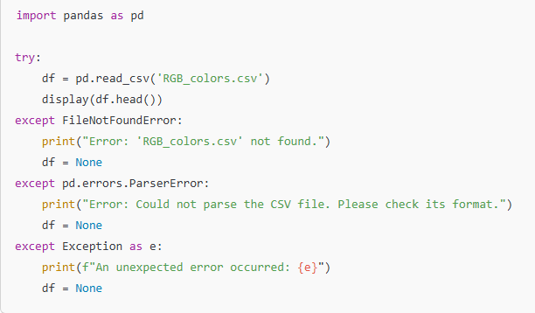**

**Data exploration**

**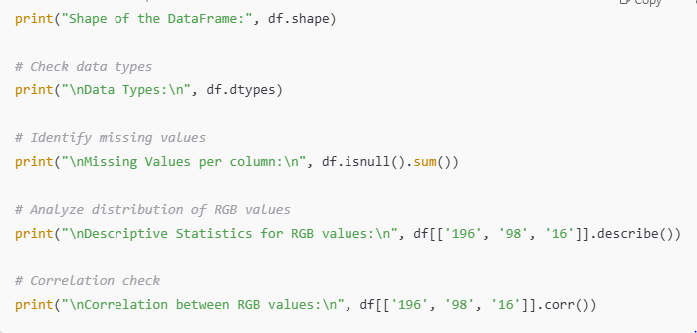**

**Data visualization**

**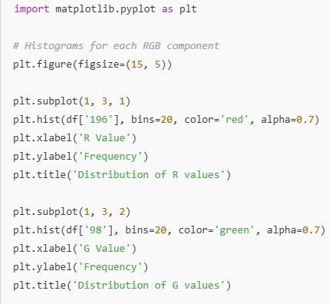**

**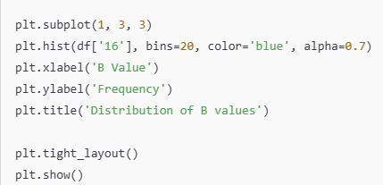**

**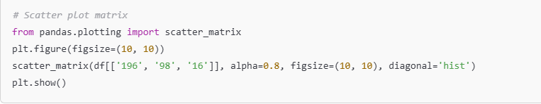**

**Data Overview**

* **DATA TYPES**

**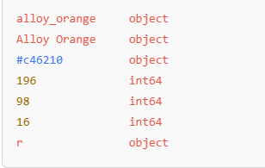**

* **MISSING VALUES**

**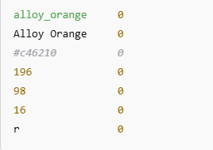**

**Detected RGB Columns**

**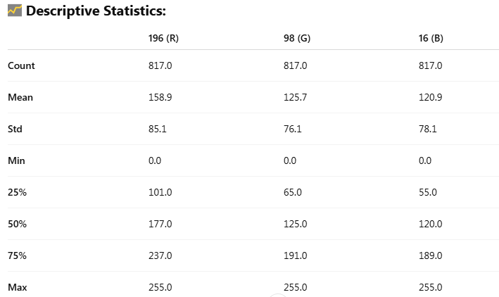**

### ****Correlation Between RGB Channels****

### pic 9.PNG

### ****Visual Outputs****rgb_histograms.png

**